

The Green Paper for Vulnerable Children,
PO Box 1556,
Wellington, 6140

Green Paper for Vulnerable Children
SUBMISSION

February 2012
This submission is being made by Family First NZ, a charitable organisation that researches and advocates on family issues in the public domain.

What does the research say about child abuse?

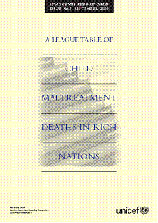
The 2003 UNICEF report “Child Maltreatment Deaths in Rich Nations” listed factors most commonly associated with the maltreatment of children including:
- drug and alcohol abuse
- family breakdown
- poverty and stress
- children not living with biological parents
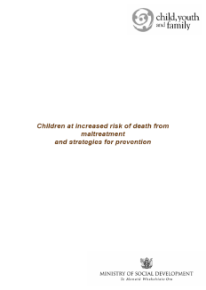
A 2006 CYF report “Children at Increased Risk of Death from Maltreatment and Strategies for Prevention” identified the following as factors which signaled greater risk for children:
- drug and alcohol abuse
- family breakdown
- poverty
- domestic violence

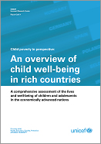
A 2007 UNICEF Report “An overview of child well-being in rich countries”said that the likelihood of a child being injured or killed is associated with
- drug or alcohol abuse
- single-parenthood / weak family ties
- poverty / poor housing
- low maternal education
- low maternal age at birth
Interestingly, in the UNICEF report, of the 10 top countries that were deemed safest and promoted the highest level of well-being for children, six hadn’t banned smacking. The safest country in the report hadn’t banned smacking. In other words, to try and suggest that a smack on the bum is child abuse is simply not true, and is an insult to good parents.

A 2009 Children’s Commissioner report entitled “Death and serious injury from assault of children aged under 5 years in Aotearoa New Zealand: A review of international literature and recent findings” said that risk factors for child abuse included:
- drug and alcohol abuse
- presence of a non-biological parent
- family breakdown, severe conflict and ongoing domestic violence
- unsupported young mothers with little or no antenatal care
- mental illness
- poverty, instability and unemployment
- ethnicity (including the high rate of abuse amongst Maori)

The issue is therefore not “what are the risk factors”.

The real issue is “what are the solutions” and are we willing to honestly accept them and then tackle them.

Key Recommendations

ONE: Establish a non-political Royal Commission of Inquiry into Child Abuse, Family Breakdown and Family Violence
Family First has been calling for a Royal Commission of Inquiry since 2007.

We have had Commission of Inquiries into the Pike river tragedy, the collapse of buildings and consequent loss of life in the Christchurch earthquake, and previous inquiries into police conduct (2004), genetic modification (2000–2001), and Auckland governance (2007-2009) – yet no inquiry into one of the greatest social problems facing the country. The issue of child abuse deserves a high priority total focus which a Commission would give.

The recent report called for by Minister Paula Bennett into just one horrific abuse case in West Auckland recently contained clear evidence that the solutions to our horrific child abuse rates lie far deeper than simply providing multiple government funded agencies and policies at the bottom of the cliff, which simply responds to child abuse.

It’s essential that we identify the root causes of family dysfunction, marriage breakdown, and violence – before the child abuse happens.

It is also essential that we remove ‘political posturing’ and ‘point-scoring’ from the process. The response of various political parties to the Green Paper proved this. The issue of child abuse needs to be removed from politicians and overseen by a Royal Commission of Inquiry.

New Zealanders support this call. In a poll of 1,000 people undertaken by Curia Market Research in March 2011, respondents were asked “Do you think an independent Commission of Inquiry into the wider causes of child abuse and family violence in NZ should be established by the Government?”

Two out of three (65%) said yes, 27% said no, and the remainder (8%) were either unsure or refused to answer. Women and younger respondents were most supportive of a commission of inquiry.

We would also remind you that at the same time as signatures were collected on the anti-smacking Referendum, almost 260,000 valid signatures were collected on a petition calling for a Referendum on whether there should be a Royal Commission of Inquiry into child abuse.

TWO: Adopt all the recommendations of the Law Commission report on Alcohol
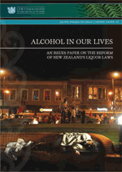
Every report we have read regarding child abuse and family violence says that alcohol abuse is a major contributing factor. A child is hugely at risk when an adult is under the influence of alcohol, and a recent survey by Massey University found that more than half of our sexual and physical assaults occurred while under the influence of alcohol. Our teenagers are binge drinking at an earlier age, and our health and justice system is clogged up with the fallout from our drinking culture.

The binge drinking culture has been increasing markedly since liberalising laws and controls around alcohol abuse. In 1989 alcohol law changes eased restrictions for off-licence selling including supermarket and grocery stores selling wine, and availability increased as trading hours of on-licence venues were extended. And then in 1999 we foolishly lowered the drinking age, allowed the sale of beer in supermarkets and further increased trading hours.

In the 2003 UNICEF report quoted earlier, 80% of child welfare professionals said “substance abuse causes or contributes to at least half of all cases of child maltreatment”. 85% of States in the US report substance abuse is one of the leading problems in families reported for child abuse. Substance abuse triples the risk for child maltreatment.

According to the World Health Organisation, a number of studies have established that alcohol is a significant contributory factor to child maltreatment, and many show that being maltreated as a child is associated with marked increases in the risk of hazardous or harmful drinking in later life.

“Findings include:
• In the USA, 35% of offenders of parental child abuse had consumed either alcohol or drugs at the time of the incident.
• In Germany, around 32 % of offenders of fatal child abuse (1985–90) were under the influence of alcohol at the time of the crime, and 37% of offenders suffered from chronic alcoholism.
• In the Northern Territory, Australia, FAS or FAE were reported in 1.7 per 1 000 live births, increasing significantly to 4.7 per 1,000 live births among the indigenous population.

Other measures of association derive from reports of harmful parental alcohol use in child welfare investigations. Such studies do not usually report whether alcohol was used immediately prior to child maltreatment but establish heavy alcohol use as a parental characteristic. For example:
• In Canada, alcohol or drug use was reported in 34% of child welfare investigations.
• In Western Australia, alcohol or drug use was a contributing factor in 57% of child out-of-home care applications.
• In London, England, parental substance use was a cause of concern in 52% of families on the child protection register, with alcohol the principle substance used.”
http://www.who.int/violence_injury_prevention/violence/world_report/factsheets/fs_child.pdf

Recent research on the connection between alcohol and other drug abuse and child maltreatment clearly indicates a connection between the two behaviours. In the US, among confirmed cases of child maltreatment, 40% involve the use of alcohol or other drugs. Additionally, research suggests that alcohol and other drug problems are factors in a majority of cases of emotional abuse and neglect. In fact, neglect is the major reason that children are removed from a home in which parents have alcohol or other drug problems. Children in these homes suffer from a variety of physical, mental, and emotional health problems at a greater rate than children in the general population. Children of alcoholics suffer more injuries and poisonings than children in the general population. Alcohol and other substances may act as disinhibitors, lessening impulse control and allowing parents to behave abusively. Children in this environment often demonstrate behavioral problems and are diagnosed as having conduct disorders.
http://member.preventchildabuse.org/site/DocServer/parental_alcohol.pdf?docID=125

THREE: Promote Marriage
The research is quite clear. Children (and adults for that matter) are safest when living with their married parents. For example;

* Married parents are less likely to neglect or abuse their children than are divorced or separated parents.
Y. Egami, “Psychiatric profile and sociodemographic characteristics of adults who report physically abusing or neglecting chil-dren,” American Journal of Psychiatry 153 (1996): 921–928.

* Children in intact married families suffer less child abuse than children from any other family structure.
A.J. Sedlak, et al., Fourth National Incidence Study of Child Abuse and Neglect (NIS–4): Report to Congress (2010): 5-19.
David Finkelhor, et al., “Sexually abused children in a national survey of parents: Methodological issues,” Child Abuse and Neglect 21 (1997): 1-9.

* Children are less likely to be injured or killed by abuse in the intact married family than in all other family structures.
Patrick F. Fagan, “The child abuse crisis: The disintegration of marriage, family, and the American community,” Backgrounder No. 1115, The Heritage Foundation, 1997.
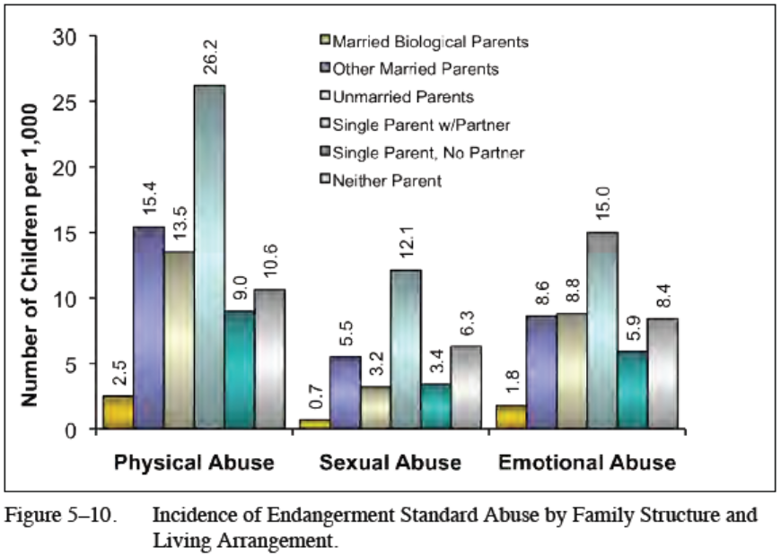
Fourth National Incidence Study of Child Abuse and Neglect (NIS–4) Report to Congress - U.S. Department of Health and Human Services 2010
http://www.acf.hhs.gov/programs/opre/abuse_neglect/natl_incid/nis4_report_congress_full_pdf_jan2010.pdf

This new federal study (above) indicates that children living with their mother and her boyfriend are about 11 times more likely to be sexually, physically, or emotionally abused than children living with their married biological parents. Likewise, children living with their mother and her boyfriend are six times more likely to be physically, emotionally, or educationally neglected than children living with their married biological parents. In other words, one of the most dangerous places for a child in America to find himself in is a home that includes an unrelated male boyfriend—especially when that boyfriend is left to care for a child by himself.
But children living with their own father and mother do not fare much better if their parents are only cohabiting. The federal study of child abuse found that children living with their cohabiting parents are more than four times more likely to be sexually, physically, or emotionally abused than their peers living in a home headed by their married parents. And they are three times more likely to be physically, emotionally, or educationally neglected than children living with their married biological parents. In other words, a child is not much safer when she is living in a home with her parents if her parents’ relationship does not enjoy the legal, social, and moral status and guidance that marriage confers on relationships.
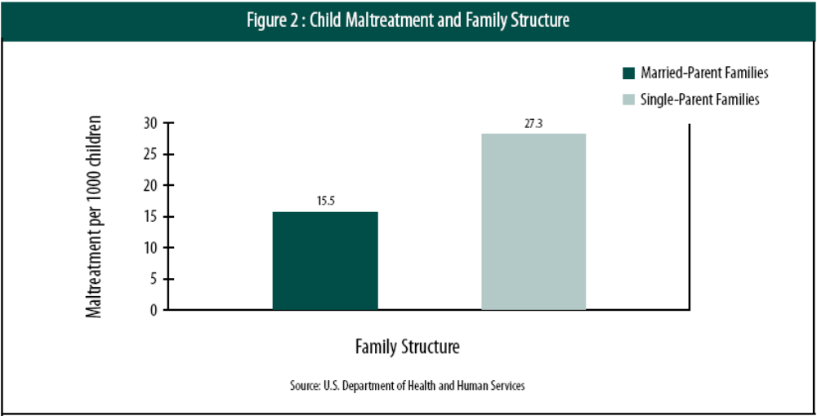

From 21 Reasons Why Marriage Matters
(www.nzmarriage.org.nz Contains all references)
“Children living with single mothers, stepfathers, or mother’s boyfriends are more likely to become victims of child abuse. Children living in single-mother homes have increased rates of death from intentional injuries. As Martin Daly and Margo Wilson report, “Living with a stepparent has turned out to be the most powerful predictor of severe child abuse yet”. One study found that a preschooler living with a stepfather was 40 times more likely to be sexually abused than one living with both of his or her biological parents. Another study found that, although boyfriends contribute less than 2 percent of nonparental childcare, they commit half of all reported child abuse by nonparents. The researcher concludes that “a young child left alone with a mother’s boyfriend experiences elevated risk of physical abuse”.
In Australia, former Human Rights Commissioner Brian Burdekin stated that there was an alarming 500 to 600 per cent increase in sexual abuse of girls in families where the adult male was not the natural father.

A 1994-95 study by the Australian Institute of Health and Welfare found that more cases of child abuse involved children from single parent families (39%) than families with two natural parents (30%) or other two-parent families (such as families with a stepparent) (21%). Of neglect cases, 47% involved children from female single parent families compared with 26% from families with two natural parents. More recent Australian research has found that the typical child murderer is a young man in a defacto relationship with the victim’s mother.

A recent study of 1998-1999 Victorian child abuse victims found that 45 per cent lived with single parents. The report, by the Australian Institute of Health and Welfare, found that children who lived in natural two-parent families had a relatively low risk of abuse. A more recent report from the same Institute entitled Child Protection Australia 1999-2000 reveals that children are most likely to be neglected or abused in single-parent families. It found that the ACT has the highest rate of maltreatment of children from female one-parent families (47 per cent), compared with 29 per cent in two-parent natural families and 18 per cent in step families or blended families. Also a newer report from the same body found that “a relatively high proportion

of substantiations [of child abuse] involved children living in female-headed one-parent families and in two-parent step or blended families”.

Finally, an Australian study of 900 coronial inquiries into child deaths found that children were far safer with their biological parents than with stepparents or no biological parents. Deakin University’s Greg Tooley said children living with a step-parent were 17 to 77 times more likely to die from intentional violence or accident.”

For the sake of our children, it is time we stopped pretending that family structure and family breakdown doesn’t matter, and started promoting a ‘marriage culture’.

FOUR: Amend the Anti-Smacking Law
DIVERTING POLICE RESOURCES:
Police figures regarding the impact of the anti-smacking law show that almost 500 kiwi families have had a police investigation for allegations of smacking or minor acts of physical discipline since the anti-smacking law was passed yet only 7% of them have been serious enough to warrant charges being laid.

It seems incredible that we are wasting time investigating hundreds of families who obviously don’t warrant that investigation, are putting those families through the stress of a potentially prolonged investigation, and are diverting valuable police resources from serious crime and rotten parents where actual abuse is happening. A law is obviously a ‘dog’s breakfast’ when there is such a high rate (93%) of cases warranting no further action by the police.

What is concerning in the figures is that the serious ‘child assaults’ show a 60% increase with 206 being recorded in a 6-month period in 2008 and that figure rising to 332 in the latest 6-month period. We quite obviously have not even begun to tackle the at-risk families with preventative measures. And, tragically, our child abuse death rate continues unabated

DIVERTING SOCIAL WORKERS FROM AT-RISK FAMILIES:
The evidence is quite clear. By mis-defining ‘child abuse’ as including a parent who smacks a child, we are diverting CYF social workers from targeting the families who should be targeted. So our notification rates are going through the roof, but this is not being matched by a proportionate matching of actual child abuse.

Note that the rate was rising dramatically well before the passing of the anti-smacking law and the It’s Not OK campaign. To blame the increase on increased awareness and reporting is misleading.

We are distracting our frontline services from focusing on at-risk children and rotten parents which is where the real focus should be.

The political obsession with banning smacking has cost New Zealand the time and resources needed to target actual child abuse, including other forms of abuse such as emotional abuse, neglect, sexual abuse and behavioural issues.

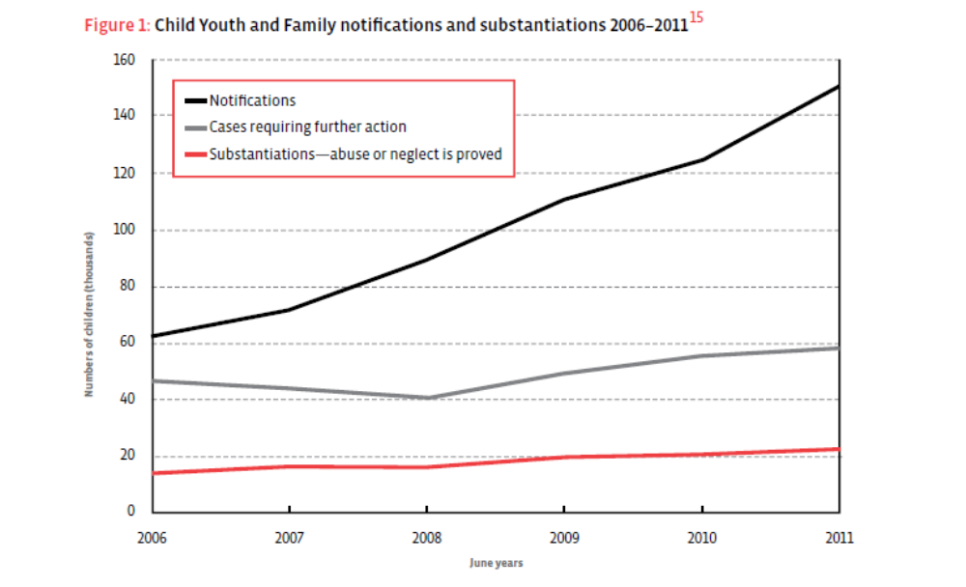

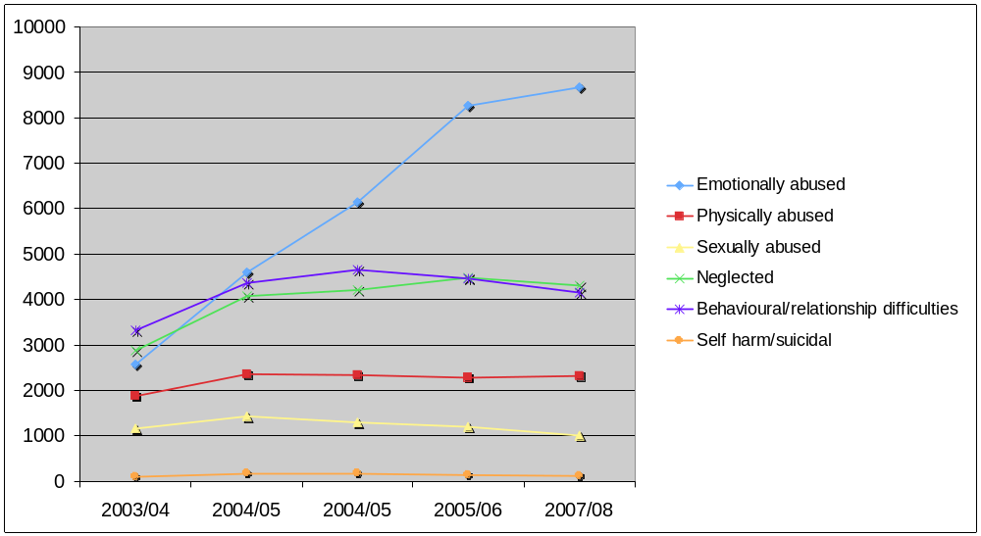

SMACKING IS NOT CHILD ABUSE:
The studies cited by opponents of smacking do not adequately distinguish the effects of smacking, as practiced by nonabusive parents, from the impact of severe physical punishment and abuse. Nor do they consider other factors that might account for problems later in life, like whether defiant or aggressive children might be more likely to be smacked in the first place. It simply assumes that the outcomes of a light smack will be the same as a child who is physically abused.

Yet research in NZ completely refutes this. A 2007 Otago University study found that children who were smacked in a reasonable way had similar or slightly better outcomes in terms of aggression, substance abuse, adult convictions and school achievement than those who were not smacked at all.

And a study by the Christchurch School of Medicine found there was no difference in outcomes between no smacking and moderate physical punishment. They said, “It is misleading to imply that occasional or mild physical punishment has long term adverse consequences”.

“While it is clear from the research that severe and harsh punishment (both physical or other) is potentially very risky for children’s development, occasional physical punishment occurs in many families and may not have long-term negative effects as long as it is used in a climate of warmth and love, where the predominant mode of relating to children is positive.”
Anne Smith, Megan Gollop, Nicola Taylor and Kate Marshall, The Discipline and Guidance of Children: A Summary of Research (Children's Issues Centre and the Office for the Children's Commissioner, June 2004)

A recent US study found that young children smacked by their parents may grow up to be happier and more successful than those who have never been hit. According to the research, children smacked up to the age of six were likely as teenagers to perform better at school and were more likely to carry out volunteer work and to want to go to university than their peers who had never been physically disciplined. Only those children who continued to be smacked into adolescence showed clear behavioural problems.

The ban on smacking was well intentioned – but flawed. It has done more harm than good. We need to allow good parents the freedom to raise great kids, and target resources at at-risk families and rotten parents where child abuse actually exists.

FIVE: Appoint an independent CYF Complaints Authority
CYF work in very difficult circumstances but it is essential that there is external accountability for their actions. We are being contacted by far too many families saying that either CYF aren’t listening or that CYF are a ‘law unto themselves’.

Children are also most vulnerable when they or their parents experience unjustified intrusion into the family and unwarranted separation. CYF are able to intervene in families without concrete and proven evidence of abuse. This power must be suitable monitored, for the sake of our children to ensure that children do not suffer ‘state-sanctioned’ child abuse.

When CYF make mistakes, the only option for families is either a costly court process where CYF have an unlimited pool of resources to defend its actions - courtesy of the taxpayer, or trying to get in front of the existing internal complaints panel.

We have long been asking for a totally independent Board similar to the Independent Police Complaints Authority. We desperately and urgently need an independent body to hear complaints about the highly sensitive nature of intervening in families. There is a Health and Disability Commissioner, a Police Complaints Authority, even a Motor Vehicle Disputes Tribunal.

Information obtained by Family First NZ under the Official Information Act shows a 150% in ex gratia payments between 2010 and 2011 - from $334,912 in 31 cases in 2010, to $836,375 in 55 cases in 2011. Ex gratia payments are made where the Ministry’s actions or performance have been deficient to a degree that the individual has suffered loss or harm.

Late last year it was revealed that CYF were planning to put two toddlers into respite care with a sexually abusive pre-teen. It was only the outrage from the grandmother that prevented a potential tragedy occurring. This followed an admission by CYF late last year that it should have done a better job protecting a nine year old West Auckland girl abused by her mother.
An independent CYF Complaints Authority will ensure that appropriate policy and procedures have been followed, will be in the best interests of the social workers, and will result in public confidence and accountability for actions and decisions by CYF workers.

An independent poll of 1,000 NZ’ers in 2011 found two out of three support the need for this Authority.

In September 2011, the Social Services Select Committee released a report recommending that the Government investigate establishing an independent CYF Complaints Authority.

The Select Committee acknowledged that ‘people whose complaints reach the Chief Executive’s Advisory Panel have to be persistent to resolve their issues’ and that they were ‘concerned to hear that the ministry does not monitor complainants’ ultimate satisfaction with the process.’

SIX: Better information sharing between agencies involved with at-risk families
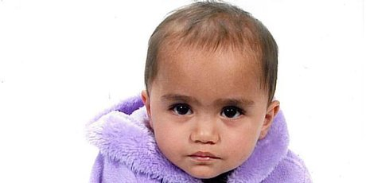
Only this week did we hear another example of Child Youth and Family failing to monitor a known at-risk family where there was previous dealings
CYF had no knowledge of Hail-Sage’s birth despite Ms Percy’s other child in its care….Hail-Sage’s death prompted the release of two Families Commission reports that look at the issue of children born into families where Child Youth and Family (CYF) have removed previous children from the parents’ care because of abuse.
http://www.nzherald.co.nz/nz/news/article.cfm?c_id=1&objectid=10787246

The Smith report on the horrific abuse of a West Auckland 9 year old showed shortfalls in collaboration and information sharing between government-funded agencies, an insufficient response when there were so many ‘red flags’, limited resources, and failings in targeting at-risk families and rotten parents in general.

The fact that the family of the West Auckland 9-year-old had been involved with 25 agencies including CYF, Waipereira Trust, Marinoto Child and Family Services, a registered ACC counsellor, a court-appointed psychologist, and the child’s court-appointed lawyer is ample proof that the ‘bottom of the cliff’ approach is not co-ordinated or effective.

We would quote directly from senior social workers Marie Connolly and Mike Doolan’s book “Lives Cut Short: Child death by maltreatment.(2007)”
“Four key elements have been identified as being important when working with (at-risk children)… First, it is important to target at-risk infants by identifying them early and developing high-quality, timely responses across the spectrum of human services. Having a shared understanding of the risk factors is important…
The other elements are building capacity to respond to diverse needs of children and families, co-ordination across agencies, and co-ordinated review and monitoring systems for infants at risk.”

We would also call for changes to be made to the Privacy Act so that information can be shared about at-risk families between agencies working with those families – the emphasis being on ‘at-risk families’ only.

WE STRONGLY REJECT THE NOTION OF MONITORING ALL CHILDREN.
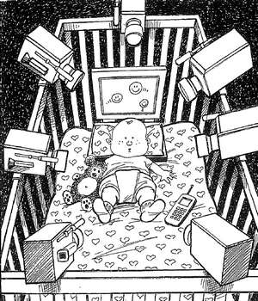
This is a waste of resources and diverts our attention away from families that are clearly at risk and known to state and community agencies.

We would once again quote directly from senior social workers Marie Connolly and Mike Doolan’s book “Lives Cut Short: Child death by maltreatment.(2007)”
“Faced with pressure to develop a ‘silver bullet’, organisations introduce more guidelines and tools, or adopt new ideological models aimed at providing a quick fix. Often these are designed to ensure that the safety-net does not miss any at-risk children. These are naïve responses that do little to address the problem. Indeed, writers have argued that such solutions have the potential to increase the risk of child abuse for many children by destabilizing families and creating an overburdened system that struggles to respond to children who really are at high risk.”

Exactly! (see Recommendation 4)

SEVEN: Improve Antenatal Care Services – especially for young parents
Mental illness, low maternal age, and unsupported young mothers feature in risk factors for child vulnerability.

We need to go back to the old ‘Plunket’ family model of supporting and working with new parents through the challenging first couple of years, responding to their needs - but the ongoing monitoring and spot checks need to be targeted where there are ‘red flags’ of drug and alcohol abuse, family violence present or past, instability and breakdown in adult relationships in the home, and signs of neglect and abuse which have been picked up by agencies, schools and doctors.

A number of the proposals contained in the Welfare Working Group Reducing Long-Term Benefit Dependency 2011 report will make significant improvements in targeting at-risk families and reducing the potential for child abuse and family violence.

Recommendations in that Report included
- requiring 16 and 17 year old sole parents to undertake training and education, parenting and budgeting programmes free of charge, and for their welfare payments to be managed
- families who are failing to meet the essential needs of their children through neglect or drug or alcohol abuse would receive forms of support including treatment and management of their welfare payments by a third party in order to provide a safe environment for their children
- requirements that parents ensure their children are attending school and having regular health checks
- at-risk families with complex needs to be provided with wrap-around services by single integrated providers which address the needs as a whole
- mandatory reporting of child abuse by agencies involved with families
- where there is a clear need for budgeting support because the child or children’s well-bring is put at risk, this may entail a provision of a ‘payment card’ programmes for use only on essential items, to ensure that children’s needs are properly met

This is not beneficiary bashing. Allowing dysfunction and dependency to harm children and locking families into poverty is the real ‘beneficiary bashing’.

Bob McCoskrie
National Director – Family First NZ
P.O.Box 276-133, Manukau City 2241
(09) 261 2426
(027) 55 555 42
bob@familyfirst.org.nz

